**DODGING GAME ADVENTURE**

Name : Yohanes Haryo Nugroho

ID : 2201840100

**1.Description**

*Concept:*

This game is basically using the same methods as space invader but with different gameplay. Anyway, the factor that makes this game different from space invader is the player has to dodge the bullet from an UFO.

**2.Design**

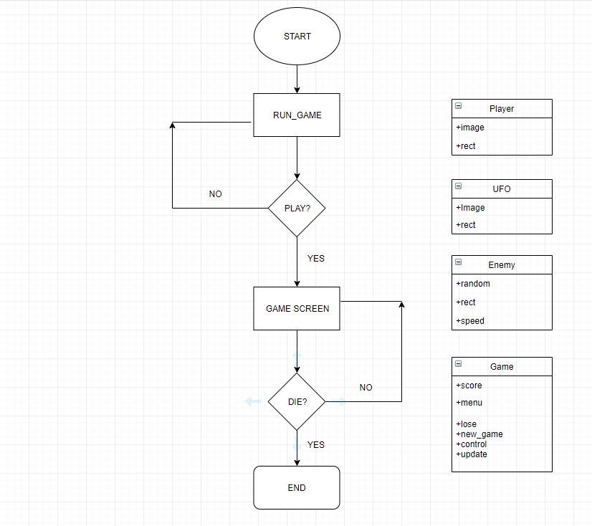

**3.Discussion**

*Implementation:*

The things that implemented within the program include:

PyGame and random.

The main framework is PyGame because this is a program and random is for spawn random bullets to dodge by the player.

*How it works:*

As soon as the program start there will be a start menu, if you press enter you will proceed to the game section. You will see a giant UFO at the top of the screen.

*Objective:*

The objective of this game is to earn score as high as possible. So, player will have a 100 health point that implemented in a healthbar beside the character of this game. The character of this game will be Iron Man.

Problems:

Since I am a beginner in coding so the problems are such thing as bug and logic implementation.

**5. Resources**

* **For Images**

[*https://google.co.id*](https://google.co.id)

* **Debugging**

Muhammad Erizky Suryaputra.

**5.Screenshots from the project**

